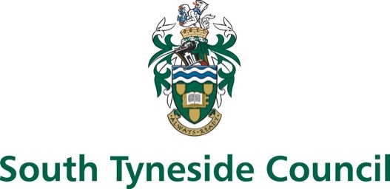

Free school meal application form

Dear Parent/Guardian,

We want to make sure that we are providing your child with the best education and support we can. Healthy school food can help pupils establish healthy habits for life and help to improve pupils’ readiness to learn.
You may be entitled to receive free school meals if you are in receipt of certain benefits or support.
You could also raise additional pupil premium funding for your child’s school to fund support like extra tuition, additional teaching staff or after school activities. The information collected in this form will allow us to make this assessment.
You only need to complete this form once. Subsequent rechecks of your eligibility will be carried out annually to assess whether you continue to be eligible for free school meals.
Should you move your child to a new school, your child’s new school may proactively assess whether you continue to be eligible for free school meals. You should contact the school or local authority if you have a change in financial circumstances.
We are committed to ensuring that the personal and sensitive information that we hold about you is protected and kept safe and secure, and we have measures in place to prevent the loss, misuse or alteration of your personal information.

We will use the information you provide to assess entitlement to free school meals. The information may also be shared with other Council departments to offer benefits and services.

What to do
To see if your children can get free school meals (FSM), please fill in all sections of this form and return it to their school.
If there is any information you cannot find, or you are having problems understanding, contact the schools for help.

Important
If you have multiple children attending different schools, you will need to complete a separate form for each school.
Please download and print separate copies to complete or contact each school.

Your details
Enter the details of the parent or guardian who is applying for free school meals.

First name

Last name

Date of birth (DD/MM/YYYY)

National insurance number (if you have one)

Asylum support reference number (previously NASS reference number)

Contact phone number (this can be a mobile number)

Contact email (We’ll use your email to address to confirm your application or for more information)

Children and school details
Include all children that will be attending this school. Print extra sheets if you need them.

Child 1

Please enter the child’s details.
First name
Last name
Date of birth
(DD/MM/YYYY)

Include details of child's previous school (optional)
School name
School postcode

Child 2

Please enter the child’s details.

First name
Last name
Date of birth
(DD/MM/YYYY)

Include details of child's previous school (optional)

School name
School postcode

Additional children
Print extra sheets if you need them.

Child

Please enter the child’s details.
First name
Last name
Date of birth
(DD/MM/YYYY)

Include details of child's previous school (optional)
School name
School postcode

Child

Please enter the child’s details.
First name
Last name
Date of birth
(DD/MM/YYYY)

Include details of child's previous school (optional)
School name
School postcode

Child

Please enter the child’s details.
First name
Last name
Date of birth
(DD/MM/YYYY)

Include details of child's previous school (optional)
School name
School postcode

Declaration

By signing below, I confirm that:

I allow the use of the data in this form for the purpose of checking whether my children are entitled to free school meals.
I allow the sharing of the above data with the schools my children attend and its local authority, for the purpose of providing free school meals if entitlement is confirmed.
This includes re-applying for free school meals in future.

Signature

Date (DD/MM/YYYY)

Important
Once completed, please give this form back to your children’s school.

